1 Write the python program to solve 8-Puzzle problem
from collections import deque
def bfs(start, goal):
queue = deque([start])
visited = set()
while queue:
state = queue.popleft()
if state == goal:
print("Reached goal:", state)
return
visited.add(tuple(state))

for i in range(len(state)-1):
new = state[:]
new[i], new[i+1] = new[i+1], new[i]
if tuple(new) not in visited:
queue.append(new)
bfs([1, 2, 3, 4, 5, 6, 7, 0, 8], [1, 2, 3, 4, 5, 6, 7, 8, 0])
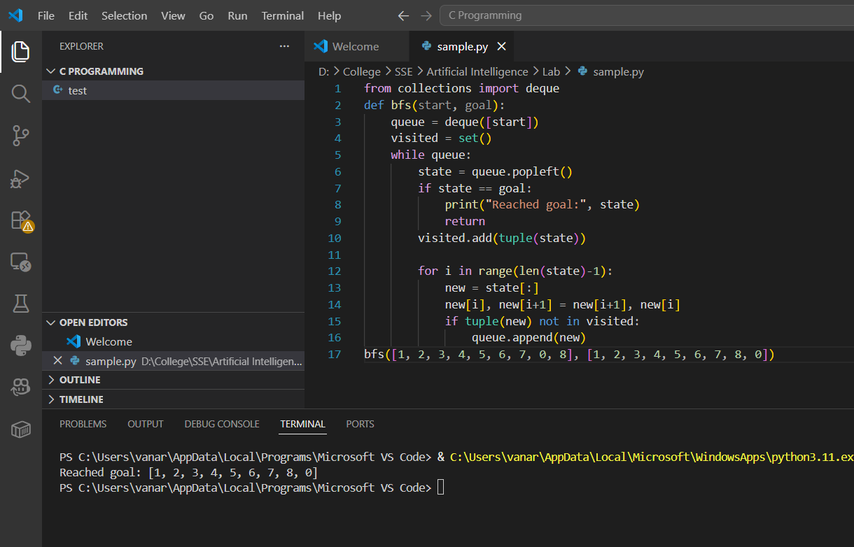
2 Write the python program to solve 8-Queen problem
def solve(n=8, y=0, board=[]):
if y == n: return [board]
solutions = []
for x in range(n):
if all(x != c and abs(x - c) != y - r for r, c in enumerate(board)):
solutions += solve(n, y + 1, board + [x])
return solutions

def print_solutions():
for sol in solve():
for row in sol:
print(" ".join(["_" if i != row else "Q" for i in range(8)]))
print("\n")

print_solutions()
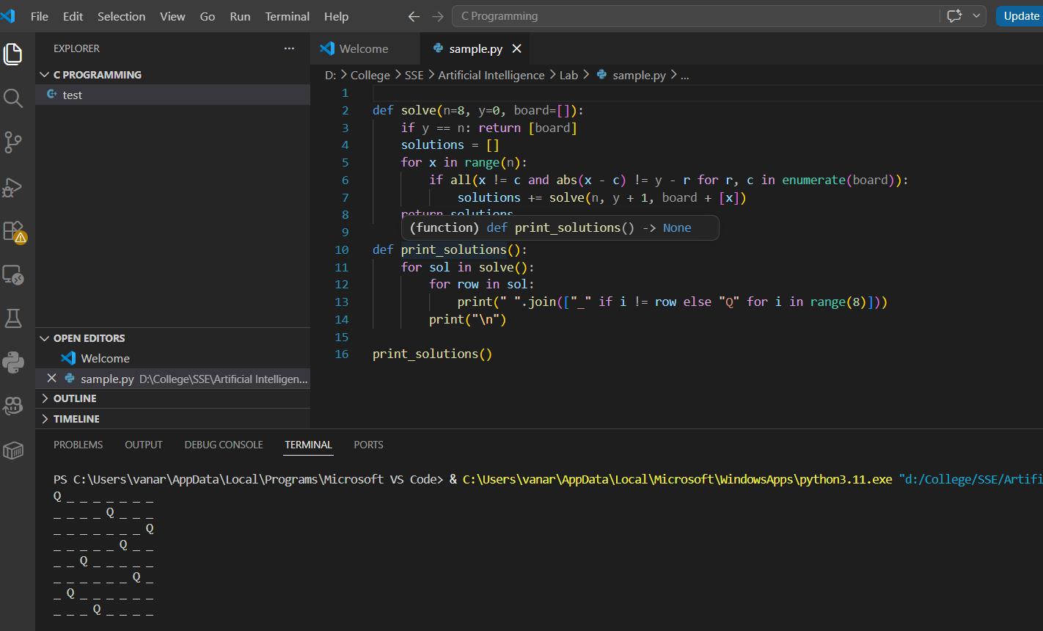

3 Write the python program for Water Jug Problem
def solve(jug1, jug2, target):
q, visited, path = [(0, 0)], set(), []
while q:
a, b = q.pop(0)
if (a, b) in visited:
continue
visited.add((a, b))
path.append((a, b))
if a == target or b == target:
return path
q += [
(jug1, b), (a, jug2), (0, b), (a, 0),
(a - min(a, jug2 - b), b + min(a, jug2 - b)),
(a + min(b, jug1 - a), b - min(b, jug1 - a))
]
return "No Solution"

def print_solution(jug1, jug2, target):
solution = solve(jug1, jug2, target)
if solution == "No Solution":
print(solution)
else:
for step in solution:
print(step)

print_solution(4, 3, 2)
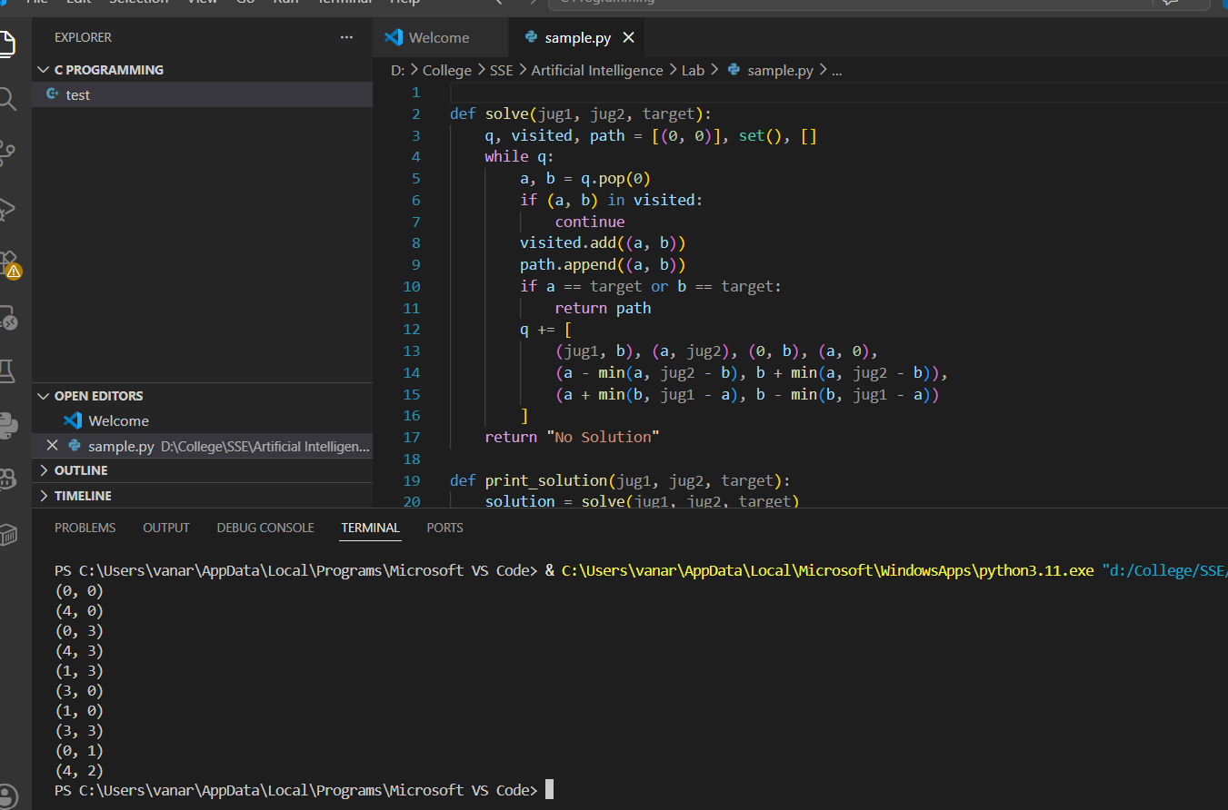

4 Write the python program for Cript-Arithmetic problem
import itertools
def solve():
for p in itertools.permutations(range(10), 8):
s, e, n, d, m, o, r, y = p
if s == 0 or m == 0: continue
send = s*1000 + e*100 + n*10 + d
more = m*1000 + o*100 + r*10 + e
money = m*10000 + o*1000 + n*100 + e*10 + y
if send + more == money:
print(f"SEND={send}, MORE={more}, MONEY={money}")
solve()
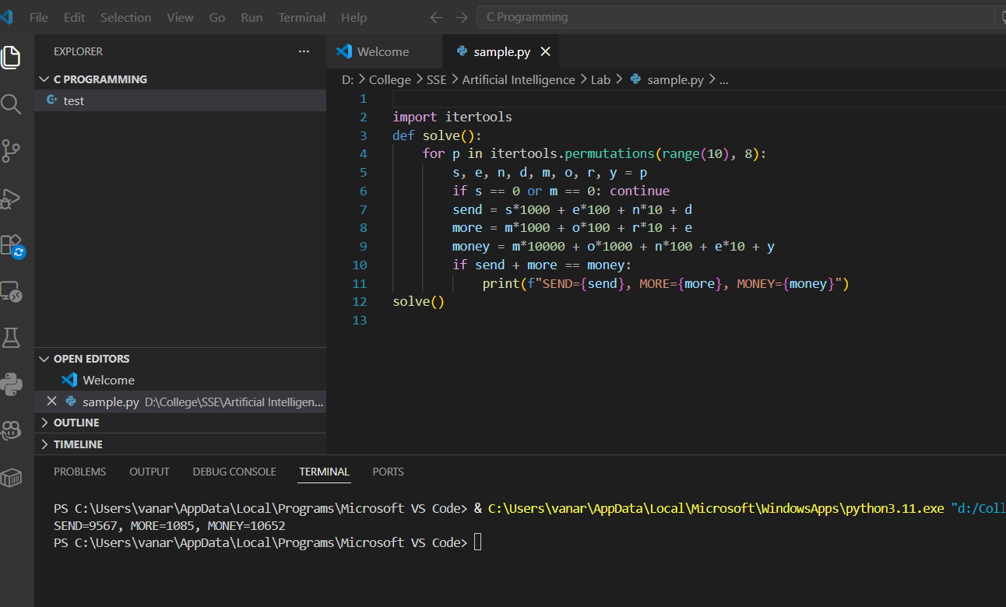

5 Write the python program for Missionaries Cannibal problem
def valid(state):
m1, c1, boat, m2, c2 = state
return (0 <= m1 <= 3 and 0 <= c1 <= 3 and 0 <= m2 <= 3 and 0 <= c2 <= 3 and
(m1 == 0 or m1 >= c1) and (m2 == 0 or m2 >= c2))

def successors(state):
m1, c1, boat, m2, c2 = state
moves = [(1, 0), (2, 0), (0, 1), (0, 2), (1, 1)]
next_states = []
for m, c in moves:
if boat:
next_state = (m1 - m, c1 - c, 0, m2 + m, c2 + c)
else:
next_state = (m1 + m, c1 + c, 1, m2 - m, c2 - c)
if valid(next_state):
next_states.append(next_state)
return next_states

def solve():
start, goal = (3, 3, 1, 0, 0), (0, 0, 0, 3, 3)
queue, visited = [(start, [])], set()
while queue:
state, path = queue.pop(0)
if state == goal:
return path + [state]
if state not in visited:
visited.add(state)
for next_state in successors(state):
queue.append((next_state, path + [state]))
return "No solution"

solution = solve()
if solution == "No solution":
print(solution)
else:
print("Steps to solve the Missionaries and Cannibals problem:")
for i, step in enumerate(solution):
m1, c1, boat, m2, c2 = step
print(f"Step {i + 1}: Left -> M:{m1} C:{c1} | Boat: {'Left' if boat else 'Right'} | Right -> M:{m2} C:{c2}")s
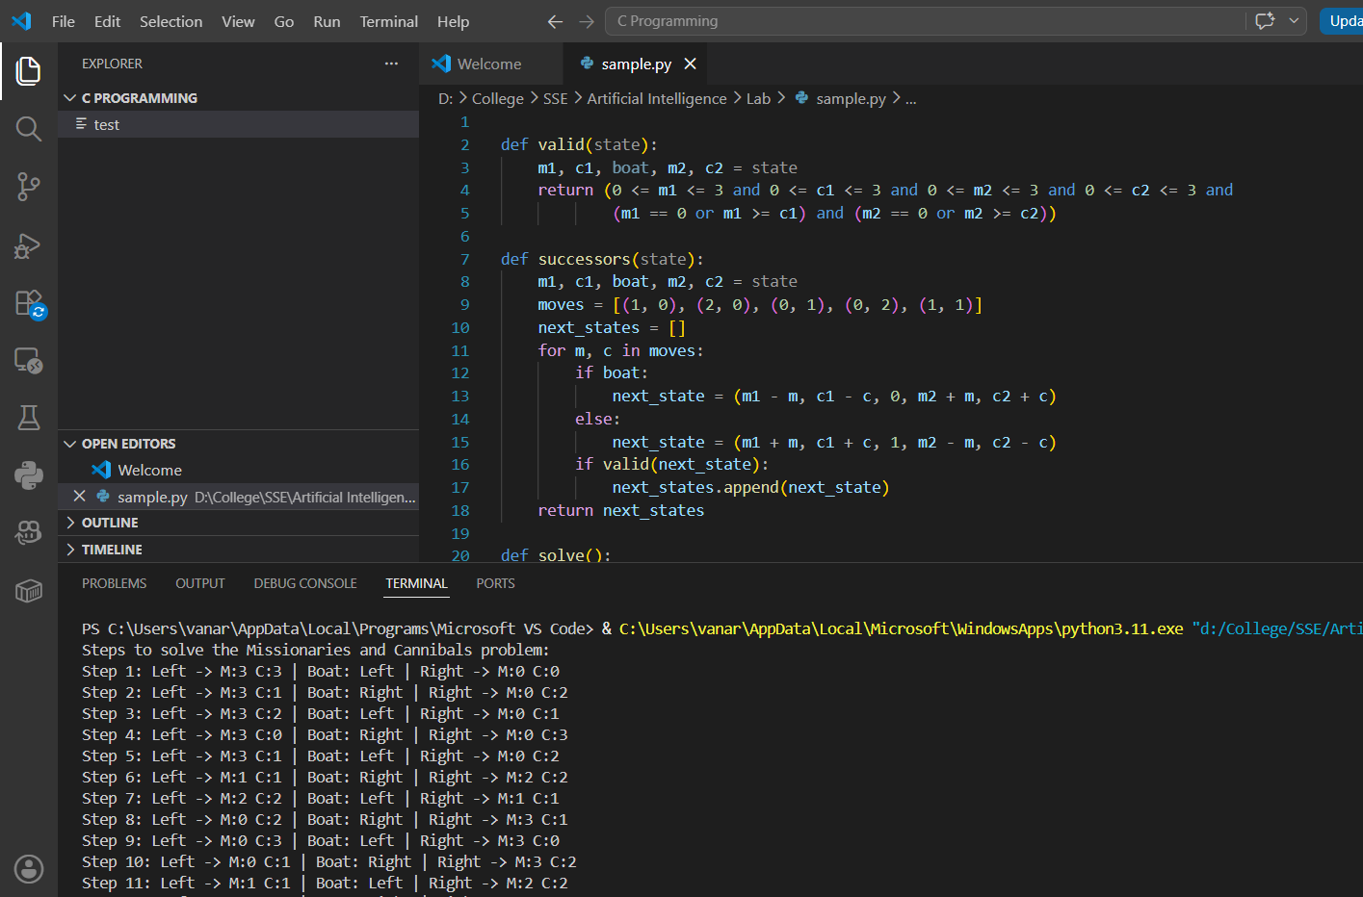

6 Write the python program for Vacuum Cleaner problem
def vacuum(env):
for room in env:
if env[room] == 'dirty':
print(f"Cleaning {room}")
env[room] = 'clean'
else:
print(f"{room} already clean")
env = {'A': 'dirty', 'B': 'clean'}
vacuum(env)
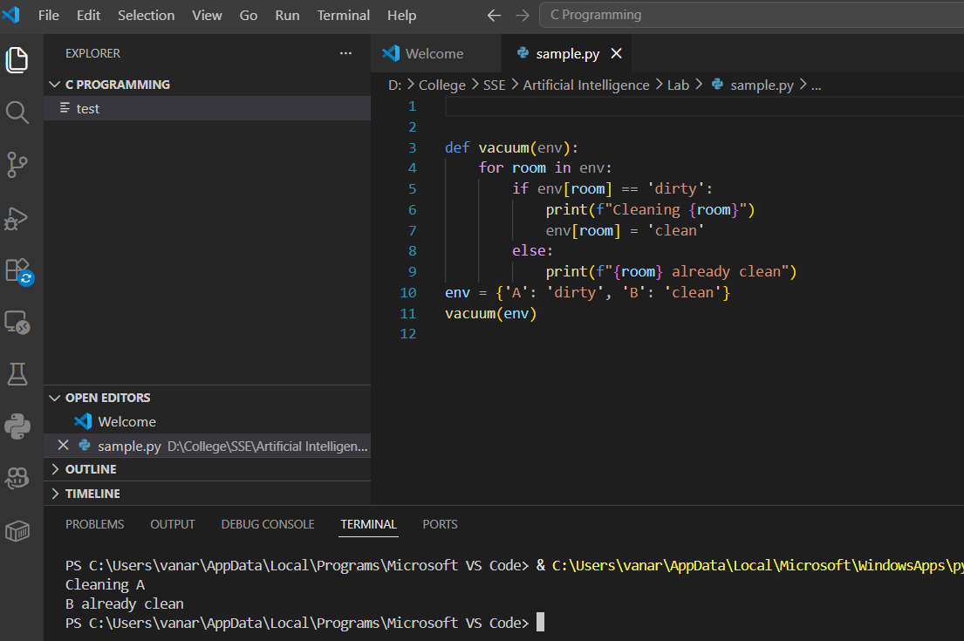

7 Write the python program to implement BFS.
def bfs(graph, start):
visited, queue = set(), [start]
while queue:
node = queue.pop(0)
if node not in visited:
print(node, end=" ")
visited.add(node)
queue.extend(sorted(graph[node] - visited))
graph = {
'A': {'B', 'C'},
'B': {'A', 'D', 'E'},
'C': {'A', 'F', 'G'},
'D': {'B'},
'E': {'B', 'H'},
'F': {'C'},
'G': {'C'},
'H': {'E'}
}

bfs(graph, 'A')
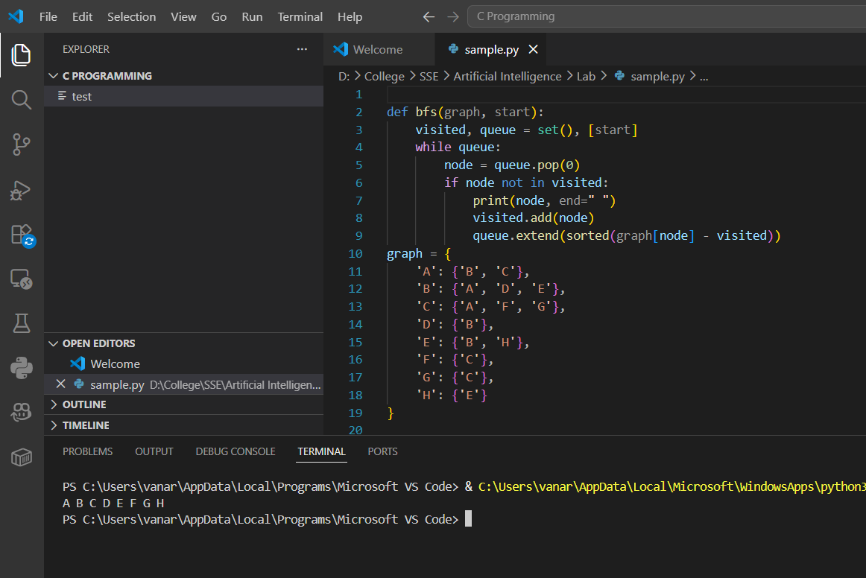

8 Write the python program to implement DFS.
def dfs(graph, node, visited):
if node not in visited:
print(node, end=" ") # Print the visited node
visited.add(node) # Mark node as visited
for neighbor in graph.get(node, []): # Visit all neighbors
dfs(graph, neighbor, visited)

# Example graph represented as an adjacency list
graph = {
'A': ['B', 'C'],
'B': ['D', 'E'],
'C': ['F'],
'D': [],
'E': ['F'],
'F': []
}

# Run DFS
visited = set()
print("DFS Traversal:")
dfs(graph, 'A', visited)
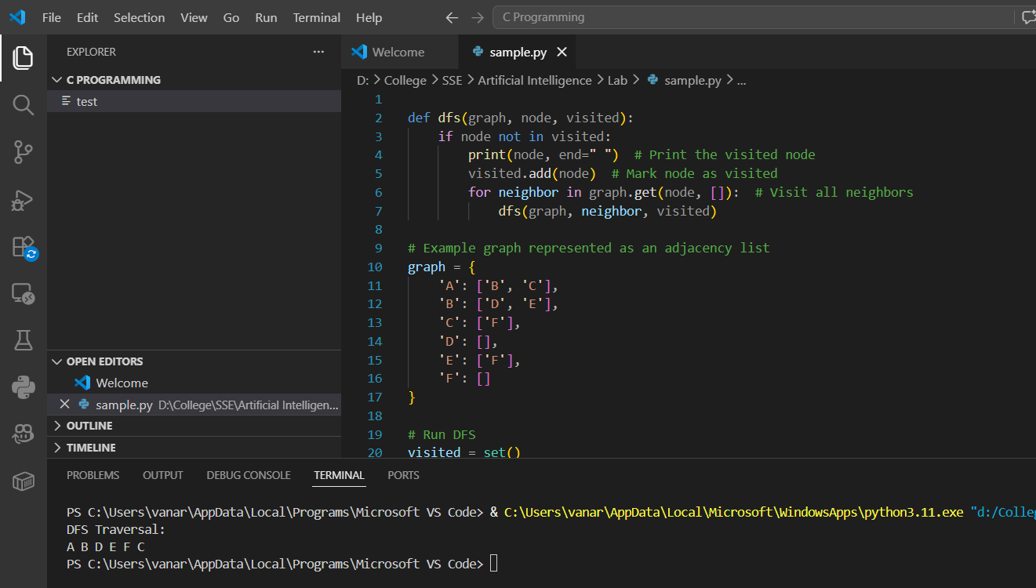

9 Write the python to implement Travelling Salesman Problem
def td(g, p):
d = sum(g[p[i]][p[i+1]] for i in range(len(p)-1))
return d + g[p[-1]][p[0]] # Return to start

# Generate all paths (backtracking)
def gt(c, s, p, v, bp, bd, g):
if len(p) == len(c):
d = td(g, p)
if d < bd[0]: bd[0], bp[:] = d, p[:]
return
for city in c:
if city not in v:
v.add(city); p.append(city)
gt(c, s, p, v, bp, bd, g)
p.pop(); v.remove(city)

# TSP function
def tsp(g):
c, s = list(g.keys()), list(g.keys())[0]
bp, bd = [], [float('inf')]
gt(c, s, [s], {s}, bp, bd, g)
return bp, bd[0]

# Graph (Adjacency matrix)
g = {
'A': {'A': 0, 'B': 10, 'C': 15, 'D': 20},
'B': {'A': 10, 'B': 0, 'C': 35, 'D': 25},
'C': {'A': 15, 'B': 35, 'C': 0, 'D': 30},
'D': {'A': 20, 'B': 25, 'C': 30, 'D': 0}
}

# Run TSP
bp, bd = tsp(g)
print("Best Path:", bp)
print("Min Distance:", bd)

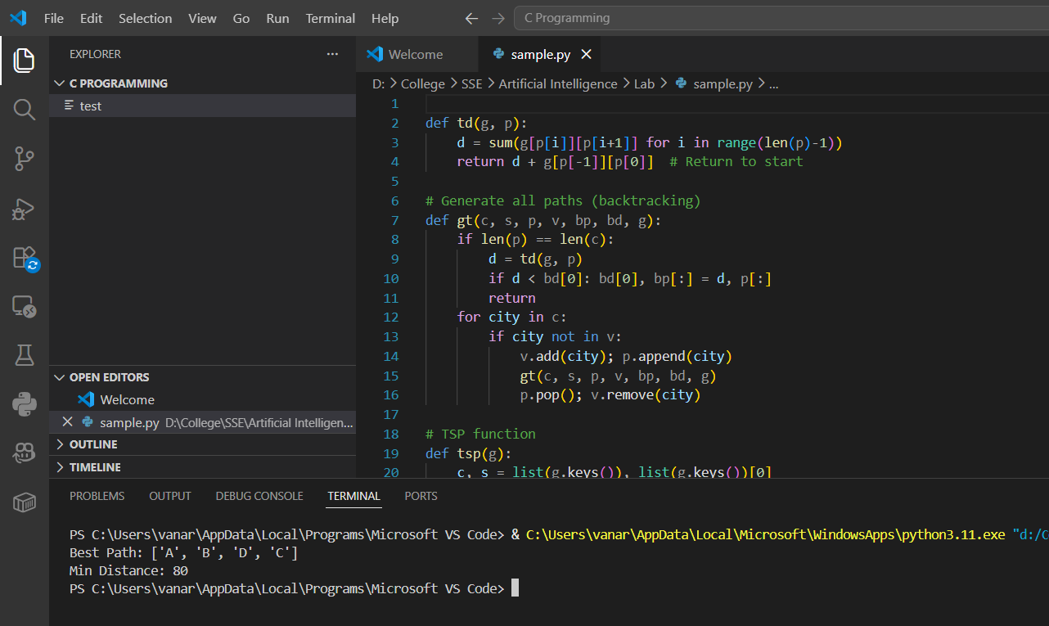

10. Write the python program to implement A* algorithm
from heapq import heappush, heappop
def a_star(graph, h, start, goal):
"""Return (cost, path) from start to goal using A*."""
open_set = []
heappush(open_set, (h[start], 0, start, None))

came_from = {}
g_cost = {start: 0}

while open_set:
f, g, node, parent = heappop(open_set)

if node in came_from:
continue
came_from[node] = parent

if node == goal:
path = []
while node is not None:
path.append(node)
node = came_from[node]
return g, path[::-1]

for nei, w in graph[node]:
new_g = g + w
if nei not in g_cost or new_g < g_cost[nei]:
g_cost[nei] = new_g
f = new_g + h[nei]
heappush(open_set, (f, new_g, nei, node))

return None, []

graph = {
'A': [('B', 1), ('C', 4)],
'B': [('A', 1), ('C', 2), ('D', 5)],
'C': [('A', 4), ('B', 2), ('D', 1)],
'D': [('B', 5), ('C', 1)]
}

h = {'A': 7, 'B': 6, 'C': 2, 'D': 0}

if __name__ == "__main__":
start, goal = 'A', 'D'
cost, path = a_star(graph, h, start, goal)
if path:
print(f"Shortest path: {' → '.join(path)}")
print(f"Total cost: {cost}")
else:
print("No path found.")
